Task 1
Complete.

Task 2
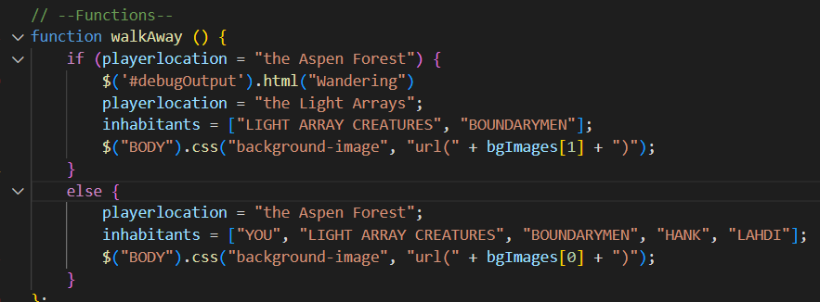
Refactor to switch statement, for further expansion later. Also, fixes the function that was broken previously; an = in place of a ==.
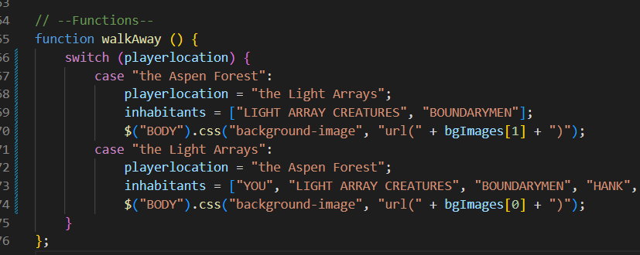
Before:
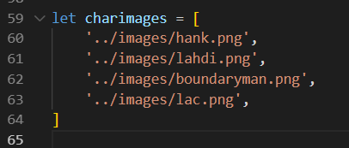
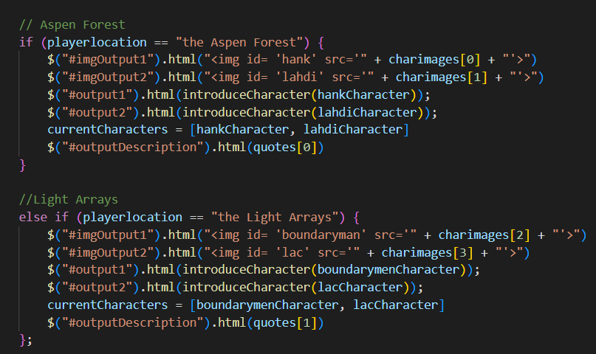
After:
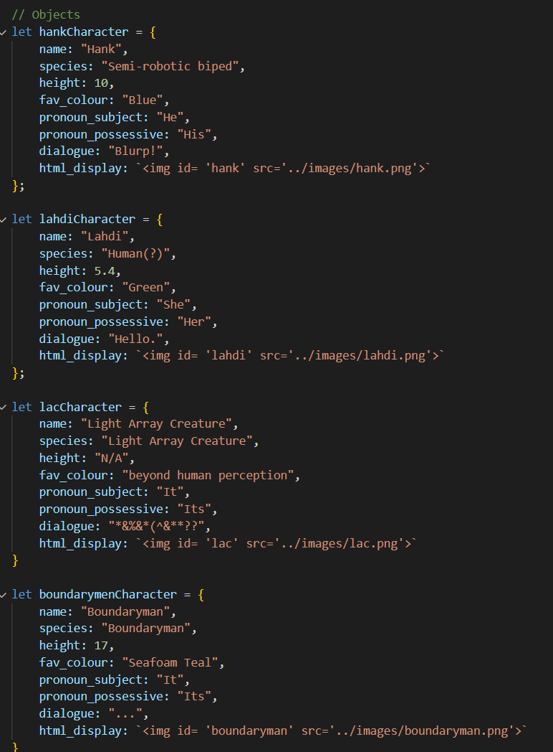
HTML goes into character objects.
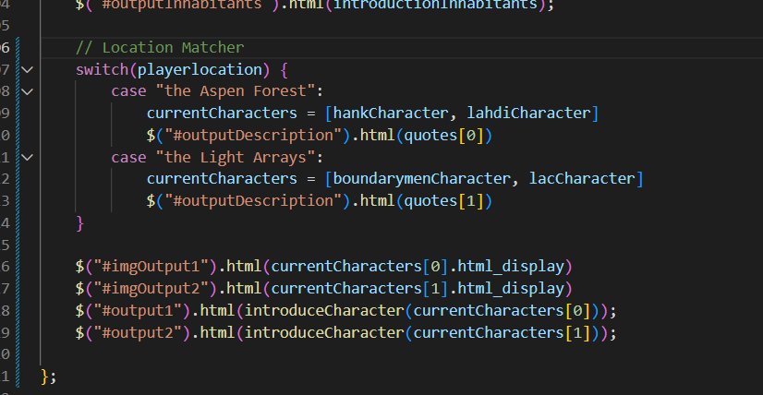
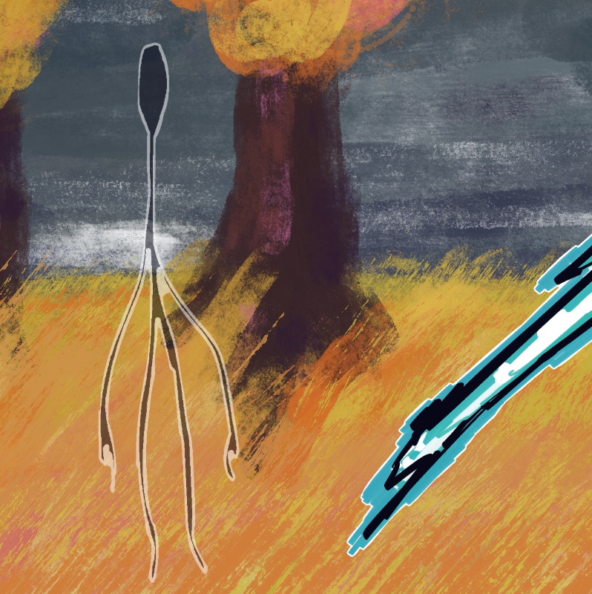
Okay. Not *quite* right. Let’s swap these bozos around.
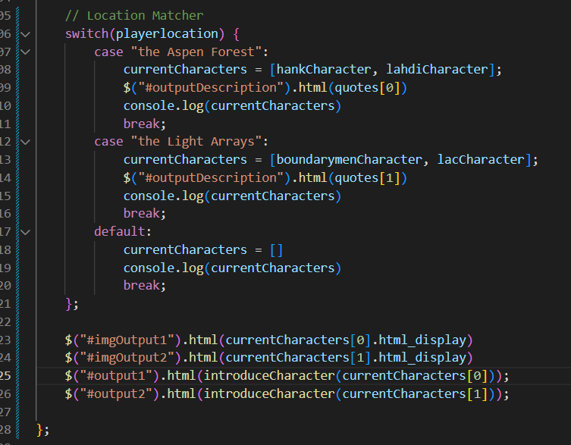
Forgot break statements. Anyways, that eliminated an entire variable and condensed a LOT of code!
Unfortunately at this point I realize I’ve refactored 60% of the code by document size, and I don’t really have anything else I can do here. This might not 100% count, but I optimized the code for the creature to make my shapes less hard-coded.
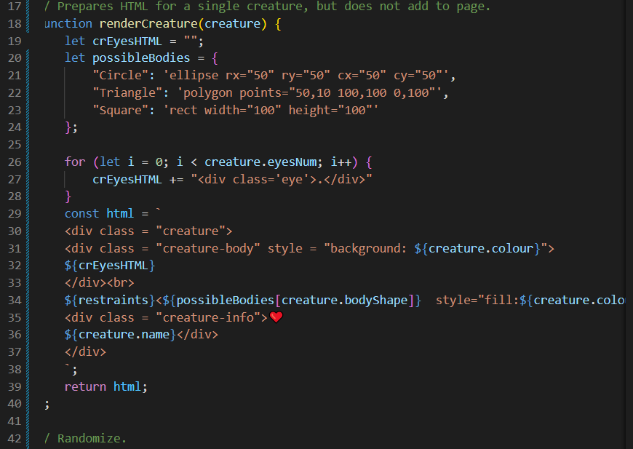
I don’t have a ‘before’ picture, because I did this for fun during class.

Task 3

https://natashamakani.github.io/ART101New/

